Graph representation

Adjacency Matrix: an adjacency matrix is a square matrix or you can say it is a 2D array. And the elements of the matrix indicate whether pairs of vertices are adjacent or not in the graph

For example:

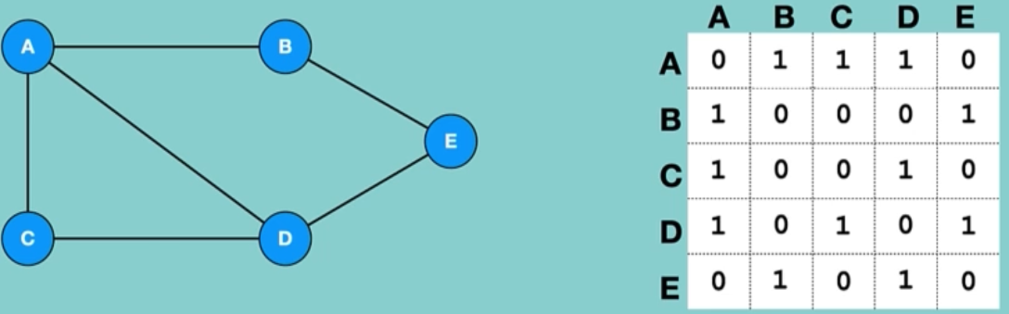

Adjacency List: an adjacency list is a collection of unordered list used to represent a graph. Each list describes the set of neighbors of a vertex in the graph.

In this case we use linked list to store all the connection from each node.

For example:

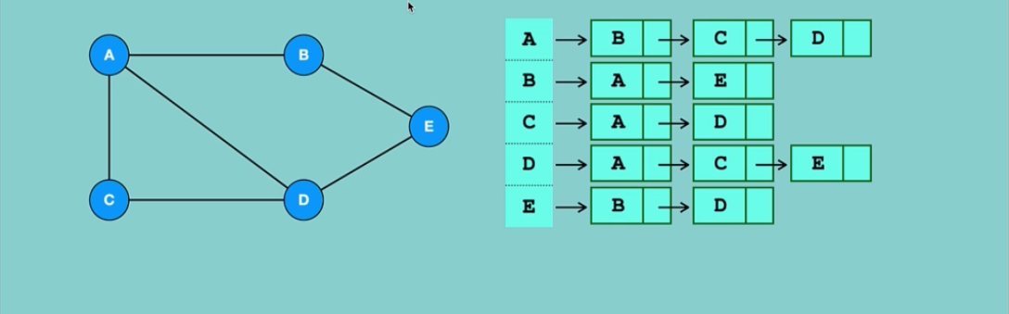

When each node is connected to most of other varsities, we shall use Adjacency Matrix

But if we have few connections (edges) in our graph, we use Adjacency List.

Once we create two-dimensional Array we cannot increase or decrees it, but with the linked list in Adjacency List we can easily delete and add elements

To implement Adjacency List we use python dictionaries, each key represent nodes

And each value fo the key represent to which node it has edge to.